Pizza Sales SQL Queries
A. KPI’s
1. Total Revenue
SELECT SUM(total_price) AS Total_Revenue
FROM pizza_sales;
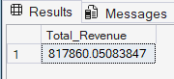
2. Average Order Value
SELECT CAST(SUM(total_price) / COUNT (DISTINCT order_id)
AS DECIMAL(10,2)) AS Avg_Order_Value FROM pizza_sales;
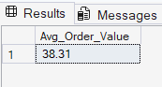
3. Total Pizza Sold
SELECT SUM(quantity) AS Total_Pizza_Sold
FROM pizza_sales;
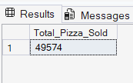

4. Total Order Placed
SELECT COUNT(DISTINCT order_id) AS Total_Orders
FROM pizza_sales;
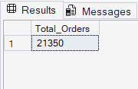

5. Average Pizza Per Order
SELECT CAST(
CAST(SUM(quantity) AS DECIMAL(10,2))/
CAST(COUNT(DISTINCT order_id) AS DECIMAL(10,2))
AS DECIMAL(10,2))
AS Avg_Pizza_Per_Order
FROM pizza_sales;
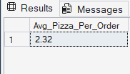

B. Problem Statement – Charts Requirement
1. Daily Trends for Order
SELECT DATENAME(DW, order_date) as order_day,
COUNT(DISTINCT order_id) AS Total_orders
FROM pizza_sales
GROUP BY DATENAME(DW,order_date);
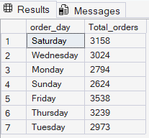

2. Monthly Trends for Order
SELECT DATENAME(MONTH, order_date) AS Month_Name,
COUNT(DISTINCT order_id) AS Total_Orders
FROM pizza_sales
GROUP BY DATENAME(MONTH, order_date)
ORDER BY Total_Orders DESC;
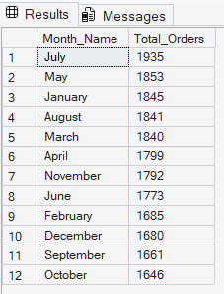

3. Percentage of Sales by Pizza Category
SELECT pizza_category,CAST(SUM(total_price) AS DECIMAL(10,2)) AS Total_Sales,CAST(SUM(total_price) * 100 /
(SELECT SUM(total_price) FROM pizza_sales )AS DECIMAL(10,2)) AS PCT_Total_Sales -- WHERE MONTH(order_date) = 3
FROM pizza_sales
-- WHERE MONTH(order_date) = 3
GROUP BY pizza_category
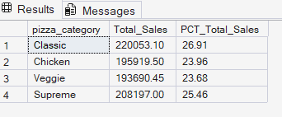

4. Percentage of Sales by Pizza Size
SELECT pizza_size,CAST(SUM(total_price) AS DECIMAL(10,2)) AS Total_Sales,CAST( SUM(total_price) * 100 /
(SELECT SUM(total_price) FROM pizza_sales ) AS DECIMAL(10,2)) AS PCT_Total_Sales
FROM pizza_sales
GROUP BY pizza_size
ORDER BY PCT_Total_Sales DESC
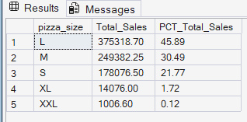
5. Total Pizzas Sold by Pizza Category
SELECT pizza_category,
SUM(quantity) AS total_pizzas_sold
FROM pizza_sales
GROUP BY pizza_category
ORDER BY total_pizzas_sold DESC;
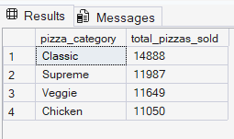

6. Top 5 best seller
SELECT TOP 5 pizza_name,
SUM(total_price) AS Total_Revenue
FROM pizza_sales
GROUP BY pizza_name
ORDER BY Total_Revenue DESC;
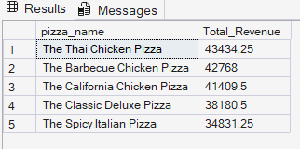

7. Bottom 5 best seller
SELECT TOP 5 pizza_name,
CAST(SUM(total_price) AS DECIMAL(10,2)) AS Total_Revenue
FROM pizza_sales
GROUP BY pizza_name
ORDER BY Total_Revenue ASC
